Shrimp Task Force Meeting
Wednesday, December 5, 2018, 10:00am
Terrebonne Council Meeting Room
8026 Main Street Houma, LA

I. Pledge of Allegiance

II. Roll call and introduction of guests

Voting Members Present:
Acy Cooper
Lance Nacio
Rodney Olander in for George Barisich
Kristen Baumer
Alan Gibson
Andrew Blanchard

Voting Members Absent:
George Barisich
Ronald Dufrene
Steve Sode

Non-voting Members Present:
Adam Aitmann
Peyton Cagle
Edward Skena
Jack Isaacs

Non-voting Members Absent:
Stephen Sessums
Justin Gremillion

III. Approval of the September 26 meeting minutes and December 5 agenda

Acy Cooper motioned to approve the September 26, 2018 meeting minutes, 2nd by Lance Nacio. Motion carries.

Andrew Blanchard motioned to approve the December 5, 2018 meeting agenda, 2nd by Alan Gibson. Motion carries.

IV. Treasury Report
Remaining Fund Balance- $522,150
Remaining Budget Balance- $94,941

Alan Gibson motioned to accept the treasury report as presented, 2nd by Andrew Blanchard. Motion carries.
V. Federal Shrimp Permit Report

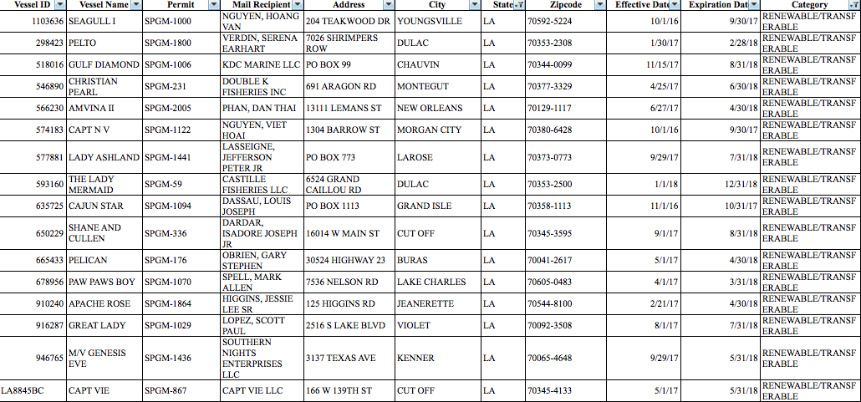

VI. New Business

The board unanimously accepted moving item A. to H.- the last item under ‘New Business’

- Jack Isaacs addressed the board with a presentation on the inflation adjusted value of shrimp landings

Rodney Olander entered at 10:30a.m.

- Mike McDonough provided the task force with a presentation on an adjustment to a nearshore planning area

- Brian Lezina provided an update on the Fishing Industry’s Adaptation Working Group

Coastal Fishing Industry Adaptation Workgroups:
The State of Louisiana recognizes the need for individuals and industry to adapt to changing environmental conditions along our coast that result from the historical ecosystem changes or integrated coastal restoration and protection efforts. The fishing industry, with a long history in coastal Louisiana, has demonstrated the need to adapt to changing coastal conditions from on generation to the next. To improve the sustainable management of the fishing industry facing these changes, the State proposes that a small working group be established to develop and evaluate possible adaptation strategies for the fishing industry and assist with the implementation of selected strategies for generations to come.

Mission Statement:
The purpose of the Coastal Fishing Industry Adaptation Workgroups (CFIAW) is to identify and evaluate adaptation strategies for the coastal fishing industries in response to a changing coast and to assist the fishing industry in implementing available strategies to improve the sustainable management of the fishing industry facing these changes.

Objectives:
- Identify issues facing the fishing industry related to changing environmental conditions (coastal land loss, water quality, integrated coastal protection efforts, etc.) to achieve sustainable management goals;
- Identify environmental, economic and policy information that can be made available, including timelines, that would be helpful in addressing changing coastal issues
- State to identify information that will help guide adaptation strategies and sustainable fishing industry efforts
- Data may be historical, current, or predictive
- Identify and discuss State restoration and protection efforts, including timing of project implementation
- Ensure that the fishing industry is kept current on both state and federal planning concerning restoration and risk reduction activities
- Provide framework for discussions on the comprehensive analysis of ecosystem, economic, and community needs to state and federal planning efforts for restoration and risk reduction efforts
- Identify adaptation strategies that are, or may be, available to the fishing industry that will assist in addressing from first item above
- Strategies suggested under this item will be further refined based on feasibility of implementation and likelihood of success
- Strategies will incorporate both short and long-term needs of the ecosystem, economic, and community components of a comprehensive approach to a sustainable fishing industry that includes both restoration and risk reduction activities;
- Identify funding sources, if necessary, that could help fishing industry fully utilize adaptation strategies from item four above

Some of the items the shrimping industry suggested for adaptation were: refrigeration on trucks and vessels, access to other fisheries, federal permits, access to other fishing areas, transitioning to other jobs, business planning, product pricing, marketing and branding

This draft of strategies will be presented to the CPRA Board in December, if all goes well there are plans to host larger public meetings in February through the spring, producing a final report to the CPRA Board sometime in late summer 2019

The task force stated that they would like to remain updated and involved on the working group and its progress

- The board discussed the current bylaws and speaking time limits

- Held discussion on the current STF vacancies

The board plans to hold a ‘Nomination Subcommittee’ meeting prior to the next STF meeting to consider new STF nominations

- The task force discussed rescheduling the Washington, D.C. trip

Alan Gibson motioned to provide funding of up to $20,000 for the Shrimp Task Force to reschedule their travel to Washington, D.C. to ‘Walk the Hill’ and host a booth in conjunction with the LA Oyster Task Force at the 2019 LA Alive event, 2nd by Acy Cooper. Motion carries.

- Acy Cooper led discussion on closed season shrimping violations

Task force members expressed concern with the September 2018 change in the inside/outside shrimp line affecting closed season shrimping violation classes; LDWF enforcement later confirmed that shrimping in closed season is still a class 4 violation

- Doug Daigle provided an update on the Gulf hypoxia action plan and Louisiana’s state strategy

The Gulf Hypoxia Task Force’s next meeting will be on January 29 in Baton Rouge

Alan Gibson motioned to pass a resolution to support the State’s continued efforts to reduce Gulf hypoxia, 2nd by Lance Nacio. Motion carries.

VII. Public Comment

Peyton Cagle reminded the task force and the public about the 2019 Shrimp Bycatch Study; still looking for commercial shrimpers who are interested in participating. Sign up as a potential participant here or contact Peyton for more information: http://www.wlf.louisiana.gov/fishing/commercial-shrimp
(Click shrimp bycatch study button)

Nicole Lundberg announced that on January 30, 2019- Beyond the Boat Seafood Processors Conference will be at LSU 4-H Mini Barn, 8:30 a.m. – 3:30 p.m. Registration: www.eventbrite.com/e/beyond-the-boat-seafood-processing-conference-tickets-49429287329
VIII. Next Shrimp Task Force meeting set for Wednesday, January 16 for 10:00am in Houma (8026 Main St. Houma, LA) with a Nomination Subcommittee meeting to be help prior for 9:00am
X. Rodney Olander motion to adjourn, 2nd by Alan Gibson. Motion carries.

